LOVELY PROFESSIONAL UNIVERSITY
Department of Finance | School of Business
Sources of Funds
Comparative Analysis of Sources of Funds: Tata Motors Passenger Vehicles Ltd, Mahindra & Mahindra Ltd, and Maruti and Suzuki India Ltd
Course: FINM542 – Corporate Finance – I
Submitted to: Dr. Anurag Pahuja
Date of Submission: 15/09/2026
Student Name | Registration No. | Section / Group
1.Neha Sambhaji Patil | 12624112 | Q1P2652
2.Debarghya Biswas | 12612819 | Q1P2652
3.Ansh Jain | 12613197 | Q1P2652
4.Shivani Sethi | 12613604 | Q1P2652
S.No | Student Name | Rating  (1-10) | Work Done By This Member | Self/Peer
1 | Neha Sambhaji Patil | 8 | Collected the data and helped with research paper. | Peer
2 | Debarghya Biswas | 10 | Made most of the research paper. | Self
3 | Ansh Jain | 7 | Helped with refinement of the document | Peer
4 | Shivani Sethi | 9 | Made PPT for video presentation and edited the video | Peer
Group Member Detail:

Mandatory Peer Rating:

Abstract
This report is aiming on what are the source of funds and capital structure of Tata Motors .along with that we also do in a comparative study of Maruti Suzuki and Mahindra Mahindra for Financial Year 2024 2025 and Financial Year 2025 2026. We get to see how Tata Motors uses debt, equity and reserves to continue its business , investment is also considered as a and financial risks and can be give different financial results for the company . Also we extend our area of study to Tata Motors’ capital intensive business which includes that related to Jaguar Land Rover’s push into electric vehicles at current state.
We are trying to compare and study the debt ratio of three companies ( TATA,MARUTI SUZUKI ,MAHINDRA & MAHINDRA) by using their annual report. We will try to do fair comparison so we looked the total number of each company but did not include the Mahindra finance part cause that can create mess in numbers of auto business.
Keywords: Sources of Finance, Capital Structure, Debt-Equity Ratio, Financial Leverage, Tata Motors, Maruti Suzuki, Mahindra & Mahindra, Indian Automobile Industry

1. Introduction

1.1 Background
Corporate finance deals with a simple question: how does a business pay for things? Whether a company needs to buy new assets or just keep running, it has to find the safest and cheapest mix of funding. Every time a company chooses to borrow money, sell shares, or dip into its own profits, it causes a ripple effect—altering the company's risk level, who controls the business, and how much money the shareholders take home
Sources of funds refers to the internal (retained earnings, reserves) and external (equity, debt, trade credit) channels used to finance a company's assets. Firms choose this mix deliberately, guided by established capital structure theories: either prioritizing internal funds (the pecking order theory) or balancing debt's tax benefits against the costs of financial distress (the trade-off theory). Ultimately, a company's chosen financing mix reveals management's risk appetite, the business's capital intensity, and its access to external capital markets.
A company's sources of funds is just the mix of internal profits and outside loans they use to pay for things. When deciding how to get cash, owners usually either spend their own money first to be safe, or they deliberately take on some debt to get tax benefits . At the end of the day, how a business chooses to fund itself tells us that exactly how its management views risk and how expensive their operations are, and whether financial markets trust them enough to lend them money

1.2 About the Company
Founded in 1945, Tata Motors Passenger Vehicles Limited (TMPVL) has a huge strong history as part of the Tata Group. the company began by manufacturing locomotives before shifting to automobiles. After playing a huge role in shaping how people travel in India and across the world, They expanded into the global stage. Today, it is a forward-thinking company whose lineup includes everyday cars, cutting-edge electric vehicles, and high-end luxury brands like Jaguar & Land Rover.

Recentlythe company renamed its consumer car division to TMPVL. This new setup brings all passenger vehicles under one umbrella: local Indian cars, new electric models, and the luxury powerhouse Jaguar Land Rover. Because of this, TMPVL now offers a complete, focused lineup that ranges from affordable everyday hatchbacks to high-end luxury vehicles.

Financially, TMPVL is a Very huge organisation . For the 2025–2026 financial year, they reported ₹3,81,922 crore in total assets and ₹1,18,842 crore in equity. the company is investing heavily in its global manufacturing, funding cutting-edge R&D, and spending aggressively to make sure both its luxury British brands and its Indian electric vehicles stay ahead of the competition.

1.3 Objective of the Study
- To understand Tata Motors Passenger Vehicles Limited's primary funding sources equity, reserves, and borrowings
- To calculate and evaluate important capital-structure ratios for Tata Motors Passenger Vehicles Limited in order to assess the financial risk suggested by its financing decisions. These ratios include the debt-equity ratio, debt ratio, equity ratio, long-term debt to capitalisation, and financial leverage.

1.4 Scope and Limitations
Scope of the Report
- The report focuses strictly on three major Indian automakers: Tata Motors (TMPVL), Maruti Suzuki, and Mahindra & Mahindra.
- The report dives specifically into corporate finance—looking at how each company funds its business, its debt-equity mix, and its overall capital structure.
- The timeframe: We used the most recent financial data available, pulling from annual reports up to the 2025–2026 financial year.
- To keep the comparison fair, we adjusted the data. For example, we looked at Tata and Maruti as whole companies, but strictly isolated Mahindra’s car/tractor business.
Limitations of the Report
- The numbers are based on year-end financial reports, which means they don't reflect sudden, real-time market changes or daily cash flows.
- Tata Motors recently went through a major demerger. The one-time costs of splitting the company temporarily messed up their profit numbers, making short-term debt analysis a bit tuff.
- The study focuses purely on the numbers. It doesn't factor in unpredictable future events, like sudden interest rate hikes, inflation, or shifts in consumer demand for EVs.

2. Literature Review
We reviewed past research across three key areas to better understand corporate financing decisions. Three key areas are-
The basic theories: How companies traditionally balance debt and equity.
Real-world evidence: How a businesses in emerging markets actually make funding choices.
Industry specifics: Research focused only on the Indian automobile sector .

2.1 Foundational Theories of Capital Structure
The invariable principle in finance was that debt and equity were about the same. But what we see in practice is that the mix of how a company chooses to fund itself is very important. To put forth how managers in fact make these decisions financial experts came up with some key concepts. Some companies use a trade-off approach which is to say they play out the tax benefits of borrowing against the risk of bankruptcy. Also some follow a pecking order which means they first use their own cash, then borrow, and only issue stock as a last option (which also may indicate the company is in trouble). Also there is a great deal of friction that happens.when you separate the people who own the company from the people running it. Ultimately, real-world data shows that a company’s size, profits, and physical assets are what truly drive these funding choices.

2.2 Capital Structure in the Indian Automobile Sector
Past research on Tata, Maruti, and Mahindra confirms what this report shows: these companies all handle their money in different way
This report tell us that a company's debt isn't driven by how big it is, but rather by its profits and growth goals. Previously, Maruti has been better at managing its daily cash flow rather than Tata Motors . But when comparing overall debt, Tata consistently relies on heavy borrowing while Mahindra prefers to stay debt-free. Even though they sell cars in the same market in India , each company have their own unique financial rules and they follow that rules .

2.3 Research Gap
Looking at all this past research, two things are clear: Indian car companies don't follow a single financial rulebook, and they generally prefer spending their own cash before taking out loans.
However, those older studies missed two very big details that change everything today. First, they were written before Tata Motors split its business in October 2025, that’s mean their old financial data doesn't reflect the company today. Second, they fell into the 'Mahindra trap'—they didn't separate Mahindra's debt-heavy banking division from its core car business, which completely skews the comparison. This new report become more accurate by fixing previous two problems .

3. Research Methodology
3.1 Data Sources
- This study relies entirely on secondary data. The primary sources are the audited financial statements published in Tata Motors Passenger Vehicles Limited's 81st Integrated Annual Report FY 2025-26 (consolidated and standalone balance sheets and statement of profit and loss).
- Mahindra & Mahindra Limited's Integrated Annual Report FY 2025-26.
- Maruti Suzuki India Limited's balance-sheet data (FY 2019-20 to FY 2025-26) was sourced from Money control.

3.2 Tools and Techniques
The study uses ratio analysis (debt-equity ratio, debt ratio, equity ratio, long-term debt to capitalisation, financial leverage, and — where the underlying profit and interest-expense data permit — interest coverage ratio), horizontal/trend analysis across available years

3.3 Period of Study
Financial Year 2024-25 and Financial Year 2025-26 (2 years)

4. Data Analysis and Findings
4.1 Shareholders' Funds (Equity Structure)
Particulars | Formula | Inputs from Annual Report (FY 2026) | Computed Result | Interpretation
TMPVL  Total Equity | Equity Share Capital+ Other Equity | Equity Share Capital=737CR Other Equity=1,11,3331CR | 1,11,842CR | This figure shows that data motors has a strong equity base . Total value 1,11,842cr
M&M  Total Equity | Equity Share Capital+ Other Equity | Equity Share Capital=601.02CR Other Equity=73,724.14CR | 74,325.16CR | M & M has total equity of 74,325.16cr. The increase in equity suggests that M&M has strengthen its shareholders funds.
Maruti Suzuki  Total Equity | Equity Share Capital+ Other Equity | Equity Share Capital=157.20CR Other Equity=1,06,999.10CR | 1,07,156CR | Maruti Suzuki has total equity of 1,07,156cr .It it showing company has not reliable on new share .

Explanation of Table 4.1 Computations and Findings

- TMPVL : The total equity is 111842 crore, it comes from equity share capital and other equity. This value represents the strong equity base of the organisation .

- M&M : Total equity of 74,325.16 crore , it’s the compounded results of equity share and other equity . This huge number indicates that organisation has strengthen its share holders funds.

- Maruti Suzuki : Maruti Suzuki has total equity of 1,07,156.30 crore and it showing that the company has not heavily reliable on new share .

Particulars | MPVL (Consol.) FY26 | TMPVL (Consol.) FY25 | M&M (Standalone) FY26 | M&M (Standalone) FY25 | Maruti (Consol.) FY26 | Maruti (Consol.) FY25
Non-current borrowings | 44,248 | 40,217 | 526.54 | 1,055.90 | 0.00 | 0.00
Current borrowings | 25,705 | 22,282 | 529.55 | 79.15 | 0.00 | 0.00
Total borrowings (interest-bearing debt) | 69,953 | 62,499 | 1,056.09 | 1,135.05 | 0.00 | 0.00
Lease liabilities (NC + current) | 9,156 | 9,041 | 597.37 | 546.74 | n/a | n/a
Trade payables | 92,780 | 97,368 | 29,499.90 | 23,405.77 | 22,133.80 | 20,501.50
Total sources of funds (= Total assets) | 3,81,922 | 3,78,642 | 1,20,602.68 | 99,648.91 | 1,48,881.00 | 1,31,971.80
4.2 Debt and Other Financing Sources, FY 2024-25 and FY 2025-26

Observation based on the table
- TMPVL has substantial interest-bearing borrowings of ₹69,953 crore in FY26
- Mahindra & Mahindra operates on a highly conservative debt-light profile, holding a negligible standalone interest-bearing debt of ₹1,056.09 crore against total assets exceeding ₹1.2 lakh crore.
- Maruti Suzuki demonstrates complete self-sufficiency and a debt-free capital structure by reporting zero long-term or short-term borrowings for both FY25 and FY26.
- All three automotive companies rely heavily on trade payables as a critical working capital source (e.g., ₹92,780 crore for TMPVL in FY26), reflecting the industry-wide adoption of supplier-financing models.

4.3 Peer Comparison
Ratio | Formula | TMPVL (Consol.) | M&M  (Standalone) | Maruti (Consol.)
Debt-Equity Ratio | Total Debt / Total  Equity | 0.59 | 0.01 | 0
Debt Ratio | Total Debt / Total  Assets | 0.18 | 0.01 | 0
Equity Ratio | Total Equity / Total  Assets | 0.31 | 0.62 | 0.72
Long-term Debt to  Capitalisation | NC Borrowings /  (NC Borrowings +  Equity) | 0.27 | 0.01 | 0
Financial Leverage  (Equity Multiplier) | Total Assets / Total  Equity | 3.27 | 1.62 | 1.39

- Debt-Equity Ratio:TMPVL's 0.59 refers that 59 paise of debt for every rupee of equity .Moderate leverage for a capital-intensive auto and luxury-vehicle business, but well above its peers. M&M (0.01) and Maruti (near 0.00) running almost entirely on equity, with borrowings playing virtually no role.

- Debt Ratio and Equity Ratio: Just 18% of TMPVL's assets are debt-funded (82% equity/other liabilities), versus 62% and 72% equity-funded for M&M and Maruti. Their remaining share is mostly non-interest-bearing items like trade payables, not borrowed money.

- Long-Term Debt to Capitalisation backs this up: TMPVL's long-term capital is 27% debt, against ~1% for M&M and effectively 0% for Maruti.

- Financial Leverage (Total Assets/Equity) :Tata is carrying significantly more debt than its rival organisation , with a leverage multiplier of 3.21x compared to Mahindra (1.62x) and Maruti (1.39x). However, while they are the most heavily leveraged of the bunch, Tata's sheer size and steady cash flow keep this debt well within a safe, manageable range.

4.4 Trend Analysis
We can only compare the last two years of data because Tata's recent demerger makes older numbers uncomparable. Over this specific period, Tata's debt ratio rise from 0.51 to 0.59. They had to borrow an extra ₹4,000 crore to keep funding JLR’s new electric lineup. Meanwhile, Mahindra’s auto division went the other way: their ratio shrank from 0.018 to 0.014 as their cash reserves grew and their borrowings dropped

Table 4.4: Maruti Suzuki — Seven-Year Trend, FY 2019-20 to FY 2025-26 (₹ crore)

Particulars | FY 20 | FY 21 | FY 22 | FY 23 | FY 24 | FY 25 | FY 26
Total  Sharehold  ers' Funds | 49,413.00 | 52,500.60 | 55,333.50 | 61,791.30 | 85,636.00 | 96,239.90 | 1,07,156.3  0
Total  Borrowing  s (LT+ST) | 111.70 | 491.60 | 381.90 | 1,215.80 | 33.10 | 0.00 | 0.00
Total  Assets | 63,627.70 | 71,282.70 | 74,655.50 | 84,596.90 | 1,15,350.8  0 | 1,31,971.8 | 1,48,881.0  0
Debt-Equit  y Ratio | 0.0023 | 0.0094 | 0.0069 | 0.0197 | 0.0004 | 0.0000 | 0.0000

Over the last seven years, Maruti’s shareholders' funds more than doubled—jumping from ₹49,413 crore to ₹1,07,156 crore—fueled entirely by their own retained profits. They completely wiped out their already tiny debt by FY 2024-25 and have stayed zero-debt ever since. It’s a textbook example of a profitable business choosing to fund its growth with the cash it generates rather than taking out loans.

When it comes to day-to-day operations, all three companies lean heavily on their suppliers for short-term financing. Instead of taking out bank loans, they use supplier credit (trade payables) to fund their inventory and production. This is a classic auto industry strategy—in fact, as researchers Chakraborty and Kumari noted in 2021, both Tata Motors and Maruti Suzuki have a history of running on negative net working capital by letting these payables cover their short-term needs.

5. Discussion
- We are seeing here Maruti Suzuki completely clearing its debt and Mahindra borrowing next to nothing is the "pecking order theory" in action.
In simple, Both companies are making so much money that they can easily pay for their own growth. They simply don’t need to go to the bank for a loan. This backs up what experts have noticed for a while: Indian businesses usually prefer to spend their own hard-earned cash rather than stressing about hitting some "ideal" level of corporate debt.
- Tata Motors (specifically TMPVL) is a whole different story. They’re actually taking on more debt, which perfectly illustrates what we call the "trade-off theory."Basically, Jaguar Land Rover is pouring a fortune into developing new electric vehicles, and they simply can't pay for it all using just their everyday profits. So, they have to borrow.
They’re making a calculated trade, they get the cash they need right now, along with some tax perks, in exchange for taking on a bit more risk.
But this does not mean they're in financial trouble . Their debt levels are still completely normal for a massive manufacturing company. It just means that out of the three companies we looked at, Tata leans the heaviest on bank loans. Because of that, they may experience increased borrowing costs if interest rates rise.
- Mahindra & Mahindra brings up a really interesting point that's easy to miss if I only look at the surface-level numbers.
There’s a massive gap between their main company debt (which is basically zero) and their total overall group debt (which looks pretty high). But this isn't bad management or a mistake—it just reflects the fact that Mahindra is essentially running two totally different types of businesses under one roof.
On one hand, you have the auto and tractor business, which barely borrows a dime. On the other, they have a massive finance company subsidiary, and finance companies naturally run on debt.If I just glanced at their total combined numbers, you’d mistakenly think Mahindra was drowning in debt compared to the others. But if I do a true apples-to-apples comparison of just the car businesses, they actually rely on bank loans the least.
- According to the report Debt numbers don't tell the whole story on their own. As an investor or manager, you have to look under the hood to understand exactly what businesses the company is running and if they are in the middle of a massive investment cycle.
This lines up perfectly with past research: having debt isn't automatically "good" or "bad" for a company's performance. There is no universal magic number. The "right" amount of debt just depends entirely on what the company does, how it's structured, and what they are building right now.

6. Conclusion and Recommendations
6.1 Conclusion
- When it comes to funding, Maruti Suzuki takes the safest route. They doubled the size of their business between 2019 and 2026, but they paid for everything using their own cash instead of taking out loans. They haven't borrowed any money from the bank since 2024.

- When it comes to actually making cars and tractors, Mahindra has almost zero debt. If you look at their total group numbers, the debt seems high, but that's just because of their finance branch, Mahindra Finance. It wouldn't make sense to look at those banking numbers and assume their car business is heavily reliant on loans."

- Tata Motors has the highest debt of the group, but it's for a good reason. They aren't struggling; they're just borrowing heavily to pay for Jaguar Land Rover's massive investment in electric vehicles. For a business this huge, their debt is still at a perfectly healthy level.
- All three companies fund their daily operations by buying on credit from their suppliers. It’s just how the auto industry works—suppliers end up financing the inventory. Interestingly, all three do this regardless of whether they have zero long-term debt or massive bank loans.

6.2 Recommendations
Based on this analysis, the following recommendations are offered for Tata Motors Passenger
Vehicles Limited specifically:

- Keep monitoring the rising debt. We're at 0.59 right now because of JLR's heavy investments in EVs. Just make sure we don't hit our internal ceiling. If company take on too much debt, borrowing gets expensive, and we'll lose our financial flexibility if things get tough.
- Because Tata's debt is creeping up, they should try to give themselves more time to pay back their current loans. Extending those deadlines would give them some breathing room, so they don't have to worry about refinancing while heavily investing in new EVs.

- Continue to grow the retained-earnings base as a funding source alongside debt, to keep the overall financing mix balanced rather than allowing debt to become the default source for incremental capital expenditure.

- The company needs to keep some backup cash or credit on hand. Because this year's profits were thrown off by the demerger, it's hard to tell exactly how easily they can cover their interest payments. We'll have a much clearer picture once the dust settles and we see a normal year of business.
- The company has about ₹9,156 crore (as of FY26) tied up in leases. While this isn't technically a bank loan, it's still a mandatory, fixed payment. When figuring out how much debt they are really carrying, it's best to just count these lease obligations as if they were regular debt.

References
Mahindra & Mahindra Limited. (2026). Integrated Annual Report 2025-26. Retrieved from
https://www.mahindra.com/annual-report-FY2026/ 2025-26.

Tata Motors Passenger Vehicles Limited. (2026). 81st Integrated Annual Report 2025-26.
https://cars.tatamotors.com/investors/financial-information/annual-reports.html

Maruti Suzuki: https://www.marutisuzuki.com/corporate/investors/company-updates
AI Usage Declaration
1. ChatGPT –.Use for re check calculation and some basic references and
2. Claude – Used for data structuring and remove unessary data
All AI-generated content was reviewed, verified, and rewritten by the authors.

PRESENTATION LINK:
https://youtu.be/Ohrf2mpFFFM?si=GBi7jhNJgV8_iTb8

Appendices
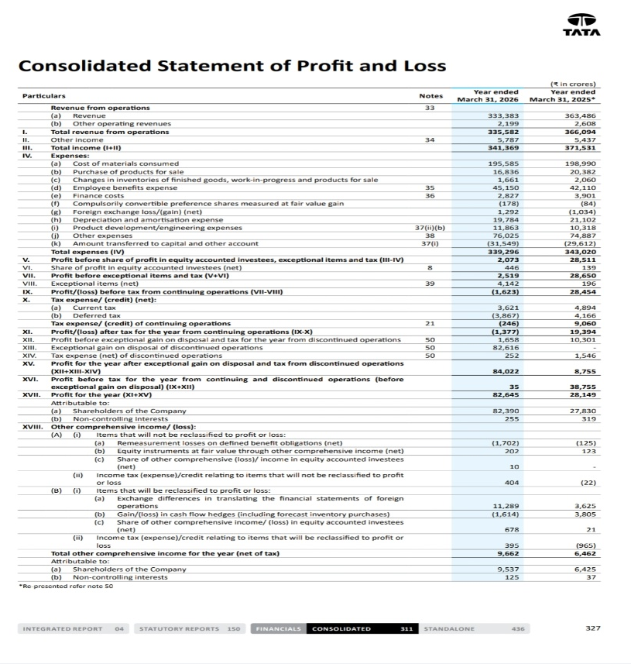 | 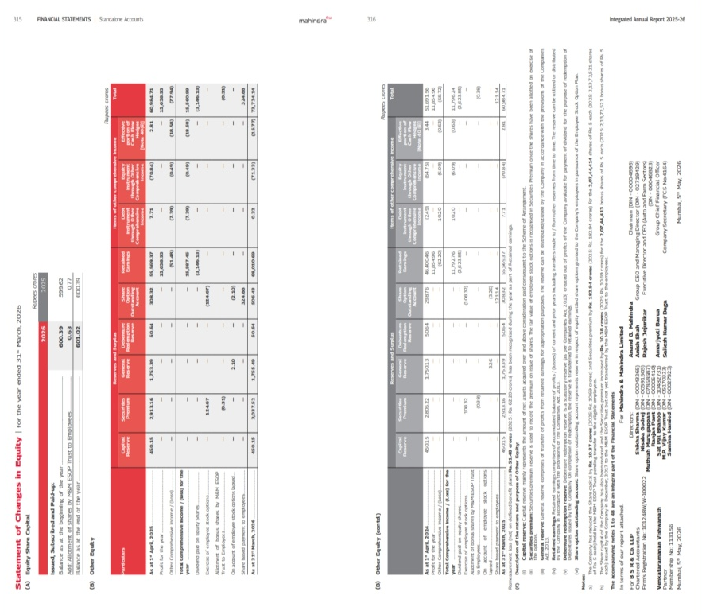
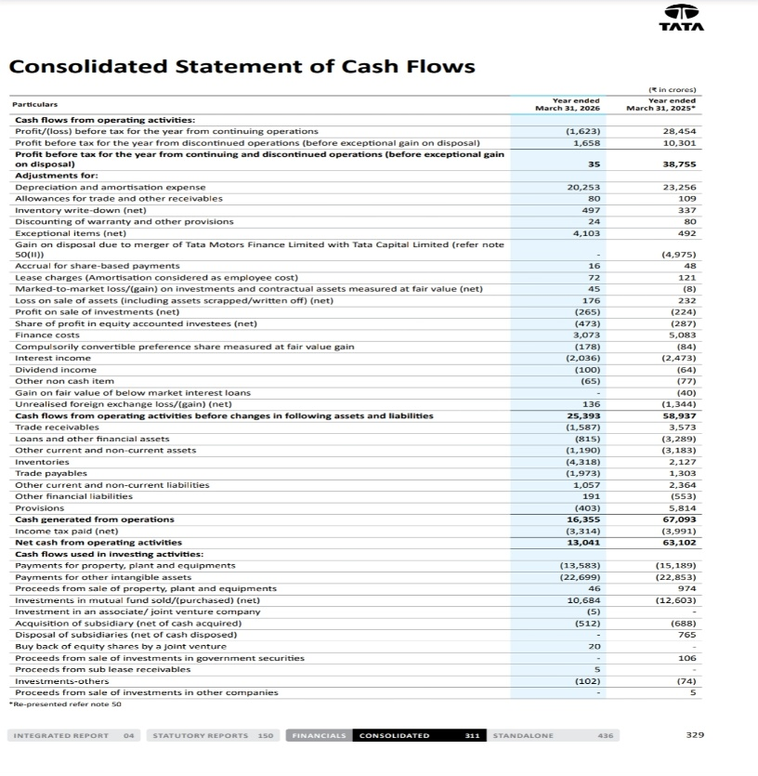 | 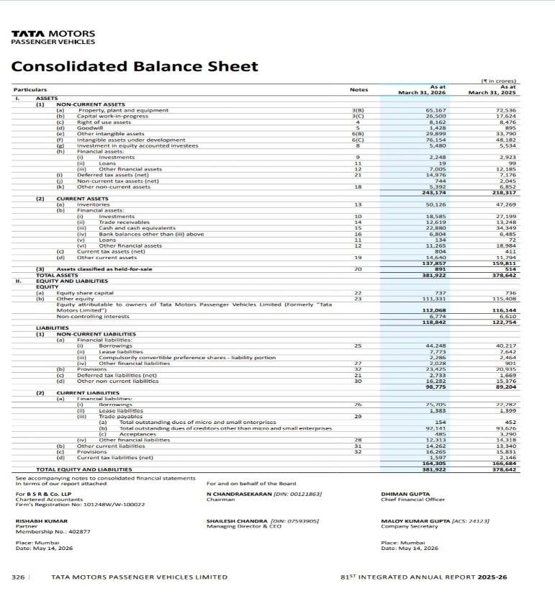

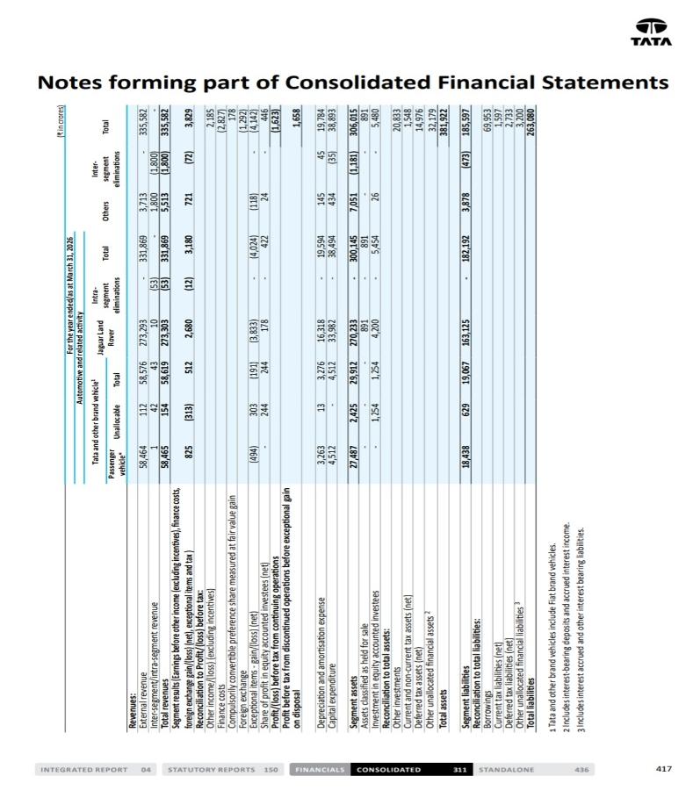 | 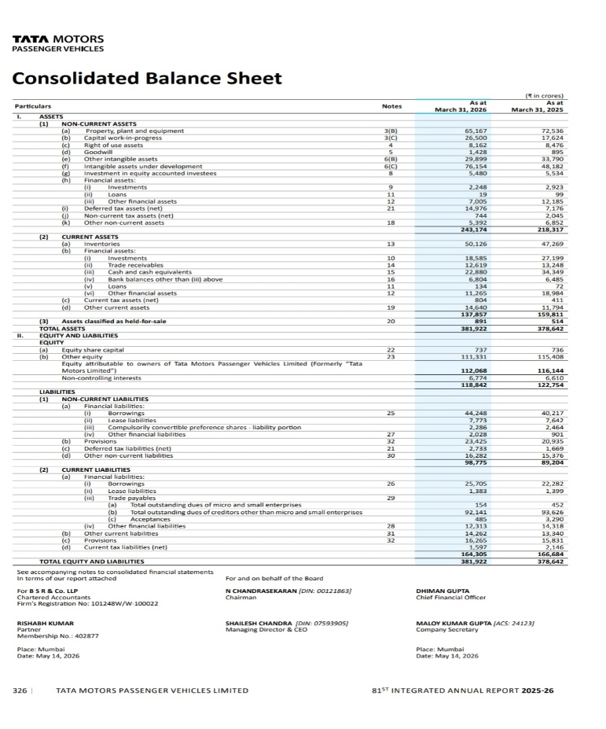
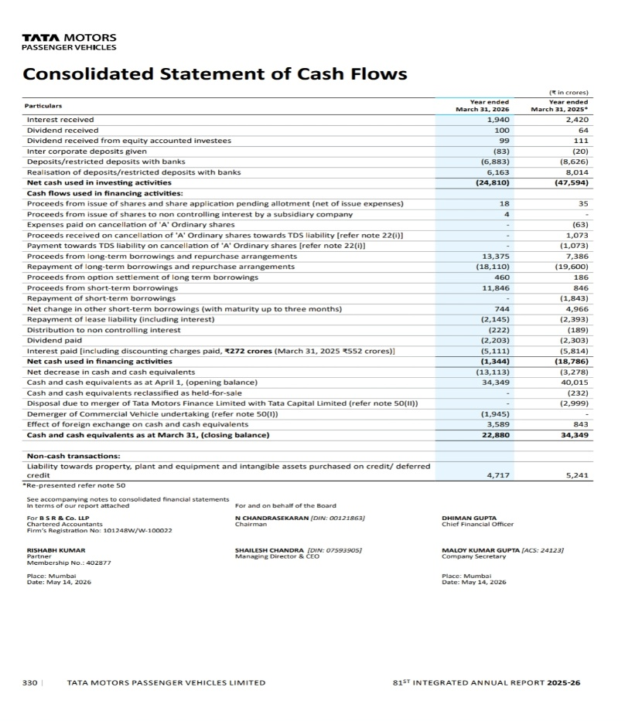 | 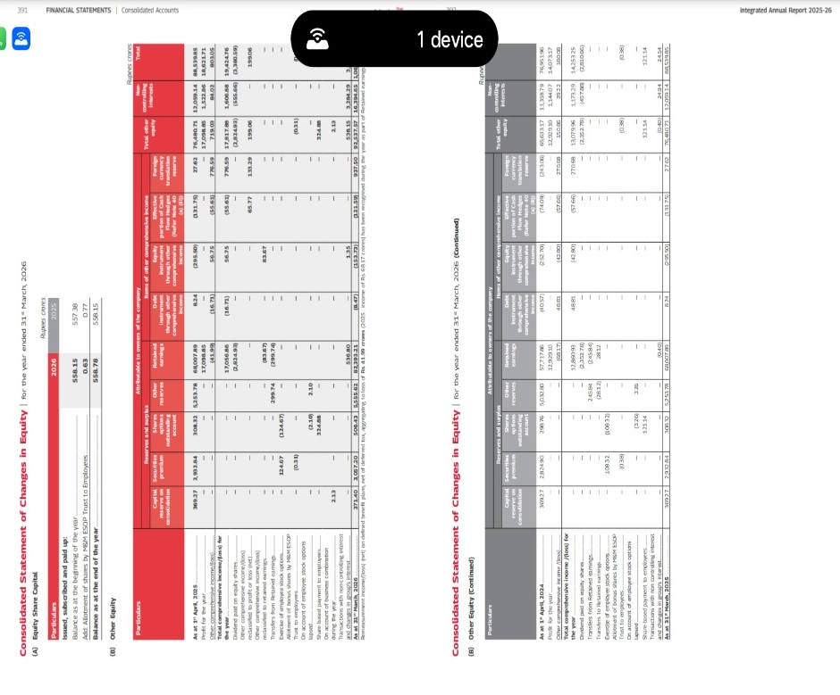

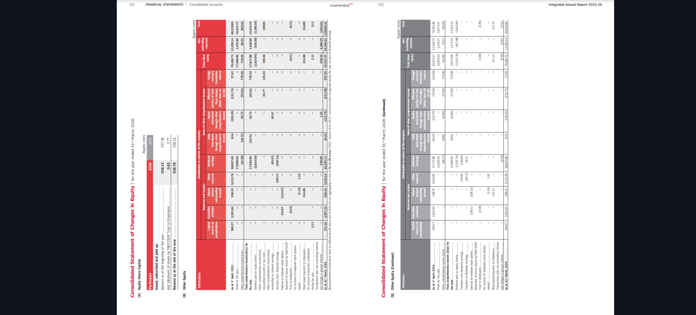
Presentation Link
https://docs.google.com/presentation/d/1OUaOXbslIUJtG4_-4h0j8eaNF3znhTGA/edit?usp=sharing&ouid=106948423996304287563&rtpof=true&sd=true

